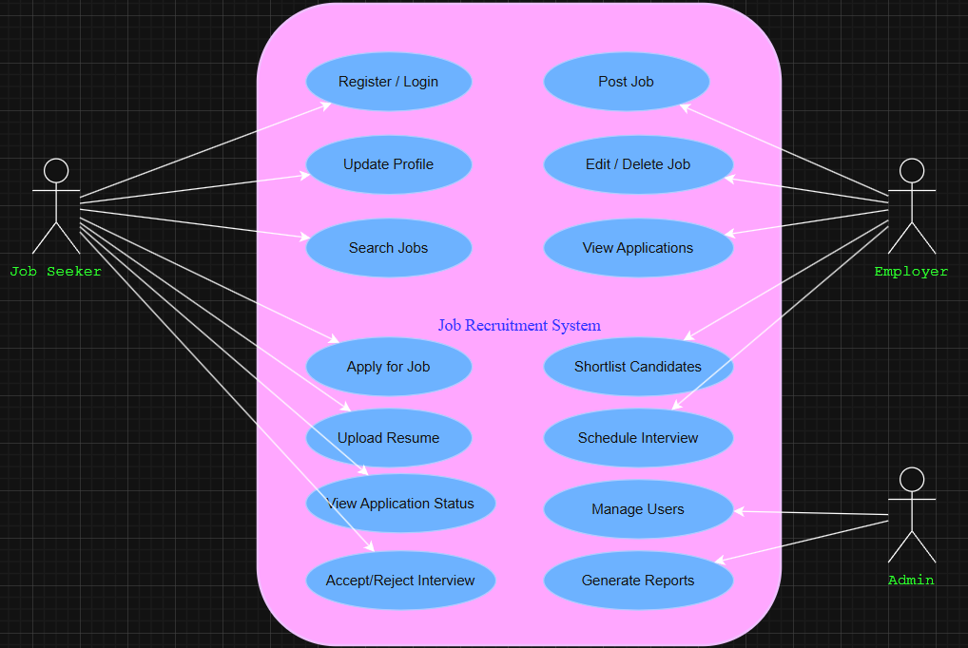

**For Job Seeker**

1. **Register / Login**
   * Allows job seekers to create an account or log in to access the system.
   * Essential for authentication and personalized services.
2. **Update Profile**
   * Enables job seekers to edit personal details, qualifications, and experience.
   * Keeps information updated for better matching with jobs.
3. **Search Jobs**
   * Provides functionality to browse or search for jobs using filters (location, skills, company, etc.).
4. **Apply for Job**
   * Allows job seekers to submit applications for job postings directly through the platform.
5. **Upload Resume**
   * Lets candidates upload their resumes to support applications.
   * Resumes are stored and used by employers for shortlisting.
6. **View Application Status**
   * Enables applicants to track the progress of their job applications (submitted, shortlisted, interview scheduled, etc.).
7. **Accept/Reject Interview**
   * Gives job seekers control to respond to interview invitations.

**For Employer**

1. **Post Job**
   * Employers can create and publish job listings with requirements and details.
2. **Edit / Delete Job**
   * Employers can update job postings or remove them if no longer available.
3. **View Applications**
   * Employers can review resumes and applications submitted for their job postings.
4. **Shortlist Candidates**
   * Functionality to filter applicants based on criteria (skills, experience, etc.) for the next recruitment stage.
5. **Schedule Interview**
   * Allows employers to arrange interviews with shortlisted candidates.

**For Admin**

1. **Manage Users**
   * Admin oversees both job seekers and employers, with rights to block, activate, or manage accounts.
2. **Generate Reports**
   * Admin can create reports (job posting stats, number of applicants, hiring trends, etc.) for analysis and monitoring.